**Basic Specifications for inBloom SxSW Reading 3D Demo**

Student List

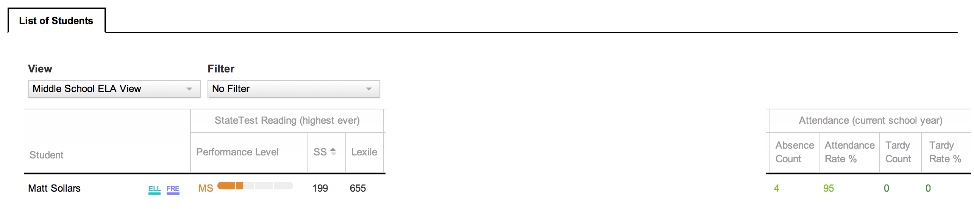

Add Most Recent Benchmark Scores for DIBELS Next & Reading 3D

|  |  |  |  |  |  |
| --- | --- | --- | --- | --- | --- |
| DIBELS Next (most recent) | | | Reading 3D (most recent) | | |
| 12-13 MOY | Performance Level | Composite Score | 12-13 MOY | Performance Level | Reading Level |

Display Score and Performance Interpretation for DIBELS Next Composite Score

Composite Score - Number

Red – Well Below Benchmark

Yellow – Below Benchmark

Green – Benchmark

Display Reading Level and Performance Interpretation for Reading 3D

Reading Level – Number

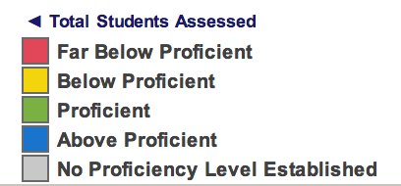

**Student Profile**

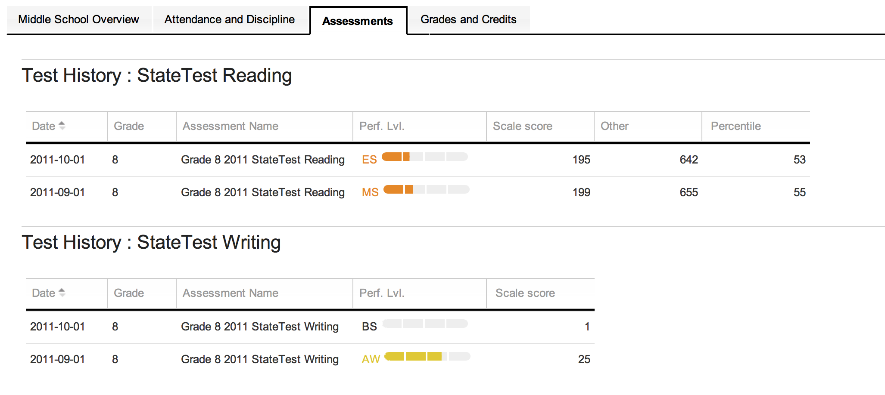

Add Test History: DIBELS Next

|  |  |  |  |  |  |
| --- | --- | --- | --- | --- | --- |
| **Date** | **Year/Period** | **Grade** | **Assessment Measure** | **Performance Level** | **Score** |
|  | 12-13 EOY | 5 | Composite | Benchmark |  |
|  | 12-13 MOY | 5 |  | Below Benchmark |  |
|  | 12-13 BOY | 5 |  | Well Below Benchmark |  |
|  | 11-12 EOY | 4 |  |  |  |
|  | 11-12 MOY | 4 |  |  |  |

Possible Assessment Measures

1. Composite
2. FSF
3. LNF
4. PSF
5. NWF (CLS)
6. NWF (WWR)
7. DORF (Fluency)
8. DORF (Accuracy)
9. DORF (Retell)
10. DORF (Retell Quality)
11. DAZE

Add Test History: Reading 3D

|  |  |  |  |  |
| --- | --- | --- | --- | --- |
| **Date** | **Year/Period** | **Grade** | **Performance Level** | **Reading Level** |
|  | 12-13 EOY | 5 | See below | Number |
|  | 12-13 MOY | 5 |  |  |
|  | 12-13 BOY | 5 |  |  |
|  | 11-12 EOY | 4 |  |  |
|  | 11-12 MOY | 4 |  |  |

Reading 3D - Performance Levels

